**CLUSTERING REPORT**



**School or Department:** Wu Han University

**Grade and Specialty:** Excellent engineer 2016

**Name:** Guo Yang, Kong Chuishun, Tang Rui

**Advisor:** Fangling Pu

April 8 2018

【**Abstract**】In this lab, we pay attention to the clustering and the K-means clustering analysis. Clustering is the task of grouping a set of objects. It is also a main task of exploratory [data mining](https://en.wikipedia.org/wiki/Data_mining), and a common technique for [statistical](https://en.wikipedia.org/wiki/Statistics) [data analysis](https://en.wikipedia.org/wiki/Data_analysis). In the engineering, we use K-means clustering. And we will use a small python lab to turn out.

**【Key words】** Python; clustering analysis; K-means clustering; data mining

**Table of Contents**

Abstract 1

Chapter 1 clustering analysis 1

1.1 definition 1

1.2 Algorithms 3

1.2.1 Connectivity-based clustering 1

1.2.2 Centroid-based clustering 1

1.2.2 Centroid-based clustering 1

1.2.2 Centroid-based clustering 1

1.2 K-nearest-neighbors algorithm 3

Chapter 2 4

2.1 Exploring KNN in Code 4

2.2 Parameter Tuning with Cross Validation 6

Chapter 3 Results and Conclusion 7

Bibliography 7

Appendix 8

**Chapter 1 Clustering analysis**

* 1. **definition**

Cluster analysis or clustering is the task of grouping a set of objects in such a way that objects in the same group (called a cluster) are more similar (in some sense) to each other than to those in other groups (clusters). It is a main task of exploratory [data mining](https://en.wikipedia.org/wiki/Data_mining), and a common technique for [statistical](https://en.wikipedia.org/wiki/Statistics) [data analysis](https://en.wikipedia.org/wiki/Data_analysis), used in many fields, including [machine learning](https://en.wikipedia.org/wiki/Machine_learning), [pattern recognition](https://en.wikipedia.org/wiki/Pattern_recognition), [image analysis](https://en.wikipedia.org/wiki/Image_analysis), [information retrieval](https://en.wikipedia.org/wiki/Information_retrieval), [bioinformatics](https://en.wikipedia.org/wiki/Bioinformatics), [data compression](https://en.wikipedia.org/wiki/Data_compression), and [computer graphics](https://en.wikipedia.org/wiki/Computer_graphics).

* 1. **Algorithms**

The following overview will only list the most prominent examples of clustering algorithms

**1.2.1 Connectivity-based clustering (hierarchical clustering)**

Connectivity-based clustering, also known as [hierarchical clustering](https://en.wikipedia.org/wiki/Hierarchical_clustering), is based on the core idea of objects being more related to nearby objects than to objects farther away. These algorithms connect "objects" to form "clusters" based on their distance. A cluster can be described largely by the maximum distance needed to connect parts of the cluster. At different distances, different clusters will form, which can be represented using a [dendrogram](https://en.wikipedia.org/wiki/Dendrogram), which explains where the common name "hierarchical clustering" comes from: these algorithms do not provide a single partitioning of the data set, but instead provide an extensive hierarchy of clusters that merge with each other at certain distances.

And the following lab is this kind of clustering analysis

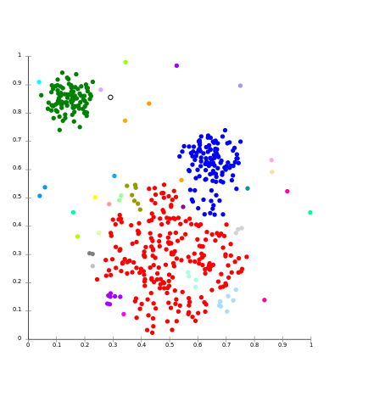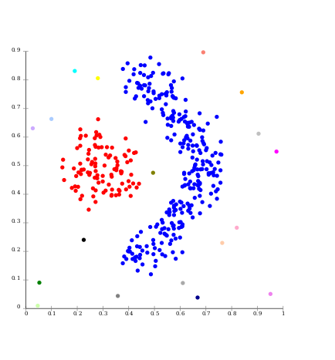

Figure 1.2.1 figure 1.2.2

Single-linkage on Gaussian data. At 35 Single-linkage on density-based

clusters, the biggest cluster starts frag- clusters. 20 clusters extracted, most

menting into smaller parts, while before of which contain single elements,

it was still connected to the second largest since linkage clustering does not

due to the single-link effect. have a notion of "noise".

**1.2.2 Distribution-based clustering**

The clustering model most closely related to statistics is based on [distribution models](https://en.wikipedia.org/wiki/Probability_distribution). Clusters can then easily be defined as objects belonging most likely to the same distribution. A convenient property of this approach is that this closely resembles the way artificial data sets are generated: by sampling random objects from a distribution. One prominent method is known as Gaussian mixture models (using the [expectation-maximization algorithm](https://en.wikipedia.org/wiki/Expectation-maximization_algorithm)). Here, the data set is usually modeled with a fixed (to avoid overfitting) number of [Gaussian distributions](https://en.wikipedia.org/wiki/Gaussian_distribution) that are initialized randomly and whose parameters are iteratively optimized to better fit the data set. This will converge to a [local optimum](https://en.wikipedia.org/wiki/Local_optimum), so multiple runs may produce different results.

Distribution-based clustering produces complex models for clusters that can capture [correlation and dependence](https://en.wikipedia.org/wiki/Correlation_and_dependence) between attributes.

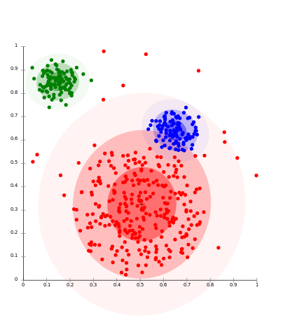 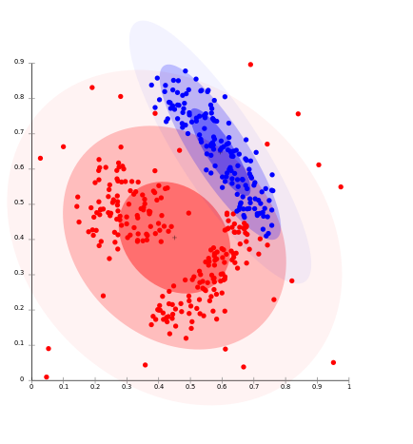

Figure 1.2.3 On Gaussian-distributed figure 1.2.4 Density-based clusters

data, EM works well, since it uses cannot be modeled using Gaussian

Gaussians for modelling clusters distributions

**1.2.3 Density-based clustering**

In density-based clustering, clusters are defined as areas of higher density than the remainder of the data set. Objects in these sparse areas - that are required to separate clusters - are usually considered to be noise and border points.

The most popular density based clustering method is [DBSCAN](https://en.wikipedia.org/wiki/DBSCAN). In contrast to many newer methods, it features a well-defined cluster model called "density-reachability". Similar to linkage based clustering, it is based on connecting points within certain distance thresholds. However, it only connects points that satisfy a density criterion, in the original variant defined as a minimum number of other objects within this radius. A cluster consists of all density-connected objects (which can form a cluster of an arbitrary shape, in contrast to many other methods) plus all objects that are within these objects' range. Another interesting property of DBSCAN is that its complexity is fairly low - it requires a linear number of range queries on the database - and that it will discover essentially the same results (it is [deterministic](https://en.wikipedia.org/wiki/Deterministic_algorithm) for core and noise points, but not for border points) in each run, therefore there is no need to run it multiple times.

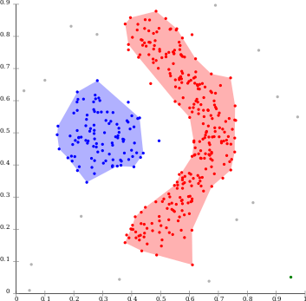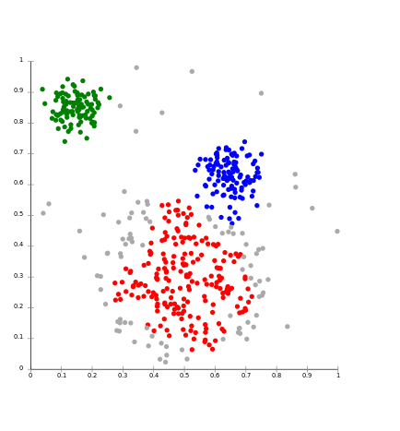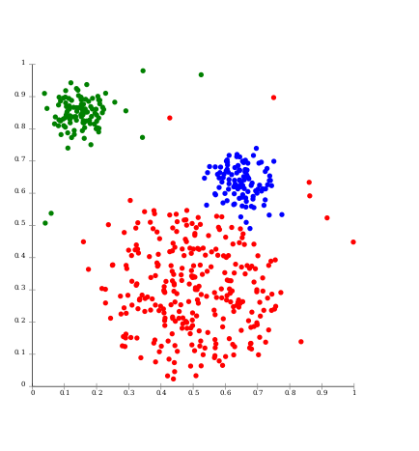

Figure1.2.5 Density-based figure1.2.6 [DBSCAN](https://en.wikipedia.org/wiki/DBSCAN) assumes figure1.2.7

clustering with [DBSCAN](https://en.wikipedia.org/wiki/DBSCAN). clusters of similar density, and

may have problems separating

nearby clusters

[OPTICS](https://en.wikipedia.org/wiki/OPTICS_algorithm) is a DBSCAN variant

that handles different densities

much better

* 1. **K-means clustering**

k-means clustering is a method of [vector quantization](https://en.wikipedia.org/wiki/Vector_quantization), originally from [signal processing](https://en.wikipedia.org/wiki/Signal_processing), that is popular for [cluster analysis](https://en.wikipedia.org/wiki/Cluster_analysis) in [data mining](https://en.wikipedia.org/wiki/Data_mining). k-means clustering aims to [partition](https://en.wikipedia.org/wiki/Partition_of_a_set) n observations into k clusters in which each observation belongs to the [cluster](https://en.wikipedia.org/wiki/Cluster_(statistics)) with the nearest [mean](https://en.wikipedia.org/wiki/Mean), serving as a prototype of the cluster. This results in a partitioning of the data space into [Voronoi cells](https://en.wikipedia.org/wiki/Voronoi_cell).

Given a set of observations (**x1, x2, …, xn**), where each observation is a d-dimensional real vector, k-means clustering aims to partition the n observations into k (≤ n) sets S = {*S1, S2, …, Sk*} so as to minimize the within-cluster sum of squares (WCSS) (i.e. [variance](https://en.wikipedia.org/wiki/Variance)). Formally, the objective is to find:

argsmin2 = argsmin $\sum_{1}^{k}{\left|Si\right|Var Si}$ 1.3.1

where μi is the mean of points in *Si.* This is equivalent to minimizing the pairwise squared deviations of points in the same cluster:

argsmin2 1.3.2

The Equivalence can be deduced from identity

2 = 1.3.3

Because the total variance is constant, this is also equivalent to maximizing the squared deviations between points in different clusters.